Telusko: Advance Java 04

149 CollectionMerging using BeanInheritance, Spring core using XML Autowiring and resolving the problem of autowiring using Primary,autowire candidate=false, Springi18N setup

CollectionMerging
-----------------
=> It should be used along with BeanInheritance
=> It can be applied only on collection/array type bean properties.
=> It is all about adding more values collection/array type property in the child
bean cfg by inheriting from parent bean cfg.
applicationContext.xml
======================
<?xml version="1.0" encoding="UTF-8"?>
<beans xmlns="http://www.springframework.org/schema/beans"
xmlns:xsi="http://www.w3.org/2001/XMLSchema-instance"
xmlns:context="http://www.springframework.org/schema/context"
xsi:schemaLocation="http://www.springframework.org/schema/beans
https://www.springframework.org/schema/beans/spring-beans.xsd
http://www.springframework.org/schema/context
https://www.springframework.org/schema/context/spring-context.xsd">
<bean id="firstYear" class="in.ineuron.comp.EnggCourse" abstract="true">
<property name="subjects">
<set>
<value>M1</value>
<value>CAD</value>
<value>Chemistry</value>
</set>
</property>
</bean>
<bean id="CS" class="in.ineuron.comp.EnggCourse" parent="firstYear">
<property name="subjects">
<set merge="true">
<value>DS</value>
<value>M3</value>
<value>C++</value>
</set>
</property>
</bean
</beans>
Output
======
EnggCourse [subjects=[M1, CAD, Chemistry, DS, M3, C++]]
Keypoints
---------
=> Collection merging is possible only with collection, array bean properties...
not on simple, object type bean properties
=> merge attribute is available only in <list>,<set>,<map>,<props>,<arry> tags
=> The possible values for merge attributes are
a. false
b. true
c. default(default)
=> Both setter and constructor injection supports the "collection merging".
Beanalias
---------
=> It refers to providing nicknames to beanid.
=> Useful when bean id is very lengthy to refer in multiple places.
=> Generally the practise to take the bean id is the classname, which isrelatively lengthy.
=> To give altername names to the bean id we should use allias.
<bean id = "wishMessageGenrator"
class="in.ineuron.comp.WishMessageGenerator">
<property name="date" ref="dt"/>
</bean>
<alias name="wishMessageGenerator" alias="wmg"/>
Autowiring
----------
Assigning the dependant class object to target class object is called "Dependancy
injection"/"AutoWiring".
=> Autowiring can be done in 2 ways
a. Explicit Autowiring/Manual Injection
a. <property name='' ref=''/>
b. <constructor-arg name='' ref=''/>
b. Autowiring/AutoInjection
<bean id ='' class='' autowire=''/>
autowire will take 3 values
a. byName
b. byType
c. constructor
Note: Autowiring is very useful becoz it helps in RAD(Rapid Application
Development).
autowire = byName
=================
=> Performs Setter Injection
=> Container detects/finds dependent spring bean class object based on id that is
matching with target class property
name(Courier courier; <bean id ='courier' class='in.ineuron.bean.BlueDart'/>)
=> There is no possiblity of ambiguity problem becoz the bean id in IOC container
are unique id's.
autowire = byType
=================
=> Perform Setter Injection
=> Container detects/finds dependant spring bean class object based on the property
type/class type in the Target
class(Courier courier;=> It is Courier type)
=> There is a possiblity of Ambiguity problem and we solve this problem by using
"primary=true" in one of the
dependent spring bean configuration.
autowire = constructor
======================
=> Performs constuctor injection using paramatereized constructor
=> Internally it follows byType approach only.
=> Ambiguity problem would arise and it can be solved using
a. primary = true on any one of the bean.
b. setting id of the bean name and parameter name of the constructor
also same.
Note: if we keep id name and consturctor param name same and in any one of the beanwith primary = true, then
constructor injection will happen by giving the priority for primary=true.
limitations of Autowiring
=========================
1. It is possible only on Object-type/reference-type bean properties.
2. There is a possiblity of getting Ambiguity problem.
3. It will also kill readability of Spring bean configuration file.
autowire-candidate = false
==========================
=>If we don't want particular beans not to participate in autowiring then we use
the above property
=>It is one more solution to resolve the problem of ambiguity which would arise in
byType.
<!-- CONFIGURING THE DEPENDANT BEAN -->
<bean id='bDart' class='in.ineuron.bean.BlueDart' />
<bean id='dtdc' class='in.ineuron.bean.DTDC' autowire-candidate="false"
primary="true"/> //invalid combo
<bean id='courier' class='in.ineuron.bean.FirstFlight' autowire-
candidate="false"/>
<!-- CONFIGURING THE TARGET BEAN -->
<bean id='fpkt' class='in.ineuron.bean.Flipkart' autowire="byType">
<property name="regNo" value='12345' />
</bean>
What is the difference b/w them?
perform Autowiring.
participate in Autowiring.
autowire = no => Disables the autowiring, programmer should explicity
autowire-candidate =false => it makes the spring bean not to
Note: The bean which is disabled through <bean id="" class="" autowire-
candidate="false"/> can be used for Explicit Autowiring.
applicationContext.xml
======================
<?xml version="1.0" encoding="UTF-8"?>
<beans xmlns="http://www.springframework.org/schema/beans"
xmlns:xsi="http://www.w3.org/2001/XMLSchema-instance"
xsi:schemaLocation="http://www.springframework.org/schema/beans
https://www.springframework.org/schema/beans/spring-beans.xsd">
<bean id="dtdc" class="in.ineuron.comp.DTDC"
autowire-candidate="false" primary="true"/>
<bean id="bDart" class="in.ineuron.comp.BlueDart"
autowire-candidate="false" />
<bean id="fFlight" class="in.ineuron.comp.FirstFlight" autowire-
candidate="false"/><!-- Configuring the Target bean -->
<bean id="fpkt" class="in.ineuron.comp.Flipkart" autowire="no">
<constructor-arg name="discount" value="10" />
<constructor-arg name="courier" ref="fFlight"/>
</bean>
</beans>
Support of I18N(Internationalization)
Making our application work for all different locale is called I18N.
Locale => Langauge+ Country
eg: en-US,en-BR,hi-IN,fr-FR,de-DE,.....
applicationContext.xml
======================
<bean id='messageSource'
class='org.springframework.context.support.ResourceBundleMessageSource'>
<property name="basename" value='in/ineuron/common/App'/>
</bean>
App.properties
--------------
#Base properties file(English)
btn1.cap = insert
btn2.cap = update
btn3.cap = delete
btn4.cap = view
App_fr_FR.properties
--------------------
#Base properties file(French)
btn1.cap = insérer {0}
btn2.cap = mise à jour
btn3.cap = supprimer
btn4.cap = voir
App_de_DE.properties
--------------------
#Base properties file(German)
btn1.cap = Einfügung {0}
btn2.cap = aktualisieren
btn3.cap = löschen
btn4.cap = Sicht
App_hi_IN.properties
--------------------
#Base properties file(HINDI)
btn1.cap = \u0921\u093E\u0932\u0928\u093E {0}
btn2.cap = \u0905\u0926\u094D\u092F\u0924\u0928
btn3.cap = \u092E\u093F\u091F\u093E\u0928\u093E
btn4.cap = \u0926\u0947\u0916\u0928\u093E
ClientApp.java
==============
// started the containerClassPathXmlApplicationContext applicationContext = new
ClassPathXmlApplicationContext("in/ineuron/cfg/applicationContext.xml");
// Prepare a Locale Object
Locale locale = new Locale(args[0],args[1]);
String cap1 = applicationContext.getMessage("btn1.cap", null, "msg1",
locale);
locale);
locale);
locale);
String cap2 = applicationContext.getMessage("btn2.cap", null, "msg2",
String cap3 = applicationContext.getMessage("btn3.cap", null, "msg3",
String cap4 = applicationContext.getMessage("btn4.cap", null, "msg4",
System.out.println(cap1 + " " + cap2 + " " + cap3 + " " + cap4);
System.out.println();
System.out.println(applicationContext.getMessage("btn1.cap",null,new
Locale("en","US")));
Locale("hi","IN")));
Locale("fr","FR")));
System.out.println(applicationContext.getMessage("btn2.cap",null,new
System.out.println(applicationContext.getMessage("btn2.cap",null,new
applicationContext.close();
Note: ctx.getMessage() internally will call ctx.getBean("id = messageSource");
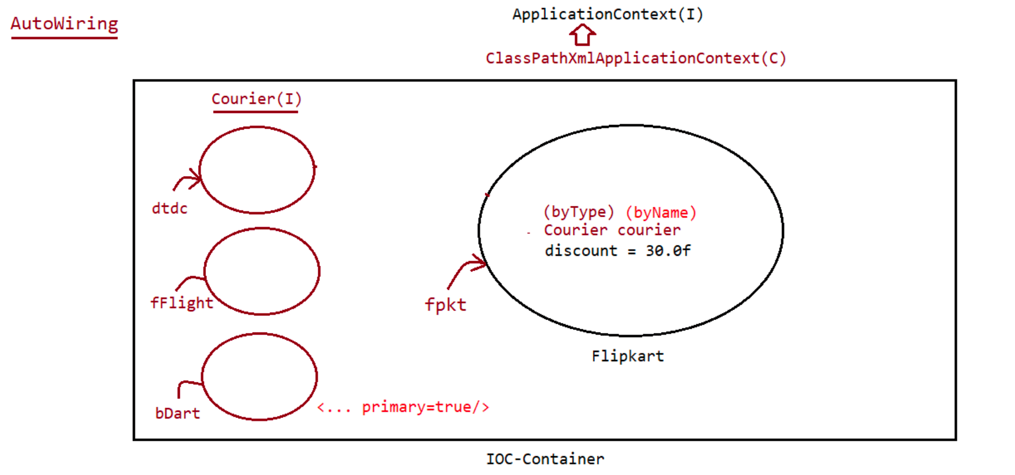

150 Pnamespace , Cnamespace, @Required , @Autowired, @Component, @Qualifier, @Lazy, @Scope, @Service, @Scope and projects on these annotations

Spring
a. DependancyInjection
1. setter sytle
syntax:: <property name="" value=""/> or <property name=""
ref=""/>
2. constuctor style
<constructor-arg name="" ref=""/>
syntax:: <constructor-arg name="' value=""/> or
p-namespace and c-namespace
===========================
=> XML schema namespace is a library that consists of set of xml tags.
=> Every xml schema namespace is identified with its namespace uri/url
=> To use xml schemaspace in our xml file we must import namespace uri/url in the
xml file.
=> Namespace for p and c is as shown below
namespace namespace uri
p
xmlns:p="http://www.springframework.org/schema/p"
c
xmlns:c="http://www.springframework.org/schema/c"
syntax for p-namespace and c-namespace
======================================
<bean p:propertyname="<value>" p:propertyname-ref="<beanid>"/>
<bean c:propertyname="<value>" c:propertyname-ref="<beanid>"/>
note: Both Container(BeanFactory,ApplicationContext) supports P-namespace,c-
namespace based programming.
Mixing up of both <property> and p-namespace, <constructor-arg> and c-
namespace is also possible.
refer:: IOCProject-21-SpringiPnameSpaceandCnameSpace
Limitations of p and c namespace
================================
1. It does not support collection merging
2. it does not support null injection
3. it does not support collection/array injection
4. It wont allow to resolve constructor params by type,index,order(resolve only by
name)
5. It came lately when industry was moving towards annotation driven programming.
List of Annotations
-------------------
1. @Configuration
2. @Required
3. @Repository
4. @Order
5. @Autowired
6. @Qualifier
7. @Scope
8. @Component
9. @Service
10.@Controller
11.@Bean
12. @DependsOn
13. @Lazy14. @Value
15. @Import
16. @ImportResource
17. @ComponentScan
18. @PropertySource
19. @Primary
20. @LookUp
21. @PostConstruct
22. @PreDestroy
Mode of Spring application development
-------------------------------------
1. XML Driven
2. Annotation driven configuration[XML + Annotation(bean code)]
3. 100% code driven cfgs(pure java/no xml)
4. Spring boot driven configuration
Annotation driven Configuration
-------------------------------
1. @Required(Deprecated from 5.1V of Spring)
=> While working with parameterized constructor injection we must
configure all params of that constructor injection.
if we fail to do it would result in "Exception".
=> This restriction is not available if we work with "Setter
Injection".
=> To bring such restriction on choice of our bean properties through
Setter injection, we need to go for
@Required.
Note:
The entire functionality of @Required annotation is placed inside a ready made
class called "RequiredAnnotationBeanPostProcessor".
So to use annotations in our application we need to configure the above class as
"Spring bean".
Configuring BeanPostProcessor for every annoation seperately is a complex process,
to overcome this problem just use
<context:annotation-config/> in spring bean configuration file.
The above code in the configuration file would activate the following annotations
@Required,@Autowired,@PostConstruct,@PreDestroy,@Resource,.....
Note:
@Required is deprecated in Spring5.1, saying to go for "consturctor-injection" in
order to add restrictions on injection.
From Spring5.1, this tag is not working for deprecated annotation like @Required.
refer:: IOCProject-22-Spring@RequiredAnnotation
2.@Autowired
=> Performs byType,byName,Constructor mode of autowiring(detecting the
dependent bean dynamically without using <property>
and <constructor-arg> tags)
=> Can be applied on field level(instance variables),constructor,setter
methods.
=> It cannot be used to inject values to simple properties, can be used to
injection values only to Object type/ref type.
=> Through annotation support, without setter/constructor still injection can be
done through "instance variables", where spring
uses "Reflection API" to access private properties of a class.=> Default Autowiring is based on byType.
eg: @Autowired
Qualifier("dtdc")
private Courier courier
eg: @Autowired
public void setCourier(@Qualifier("fFlight") Courier courier) {
this.courier = courier;
System.out.println("Flipkart.setCourier()");
System.out.println(this);
}
applicationContext.xml
======================
beans xmlns="http://www.springframework.org/schema/beans"
xmlns:xsi="http://www.w3.org/2001/XMLSchema-instance"
xmlns:context="http://www.springframework.org/schema/context"
xsi:schemaLocation="http://www.springframework.org/schema/beans
https://www.springframework.org/schema/beans/spring-beans.xsd
http://www.springframework.org/schema/context
https://www.springframework.org/schema/context/spring-context.xsd">
<bean id="dtdc" class="in.ineuron.comp.DTDC" />
<bean id="bDart" class="in.ineuron.comp.BlueDart"/>
<bean id="fFlight" class="in.ineuron.comp.FirstFlight" />
<!-- Configuring the Target bean -->
<bean id="fpkt" class="in.ineuron.comp.Flipkart">
<property name="discount" value="30" />
</bean>
<context:annotation-config /><!--Enabling the Autoconfiguration -->
</beans>
refer:: IOCProject-23-Spring@AutowiredAppInstanceandSetterApp
Flipkart.java
============
@Autowired
public Flipkart(@Qualifier("bDart") Courier courier) {
this.courier = courier;
System.out.println("Flipkart:: One Param constructor...");
System.out.println(this);
}
applicationContext.xml
======================
<beans xmlns="http://www.springframework.org/schema/beans"
xmlns:xsi="http://www.w3.org/2001/XMLSchema-instance"
xmlns:context="http://www.springframework.org/schema/context"
xsi:schemaLocation="http://www.springframework.org/schema/beans
https://www.springframework.org/schema/beans/spring-beans.xsd
http://www.springframework.org/schema/context
https://www.springframework.org/schema/context/spring-context.xsd">
<bean id="dtdc" class="in.ineuron.comp.DTDC" />
<bean id="bDart" class="in.ineuron.comp.BlueDart"/><bean id="fFlight" class="in.ineuron.comp.FirstFlight" />
<!-- Configuring the Target bean -->
<bean id="fpkt" class="in.ineuron.comp.Flipkart"/>
<context:annotation-config />
</beans>
SteroType Annotation
--------------------
=> We have multiple annotations with similar behaviour.. having minor differences
so they are called as "Stereotype annotations".
@Component ====> To configure java class as Spring bean
(bean will be created and it is managed by IOC
container)
@Service =====> @Component + also makes the service class by giving
Transaction management support(Spring AOP)
@Repository =====> @Component + also makes the DAO class by Exception
propogation facilities(SQLException to Spring specific Exception)
@Controller =====> @Component + also makes the Controller class getting the
facility of handling HttpRequests.(SpringMVC)
Note: To make IOC container going to different specified packages and their
subpackages to search and recognize steroannotations classes
as SpringBean we need to place <context:component-scan package =""/> in xml
file.
=> These stereo-annotations should be applied only at the class level.
Annotations used for lazy loading, keeping the beans in particular scope, and
getting values from properties file
===================================================================================
==============================
@Lazy ===> On the bean it would perform Lazy Loading
@Scope ==> It specifies the scope in which the bean should be kept.
@PropertySource(value="") => It specifies the location from where the properties
file data should be taken.
DTDC.java
=========
@Component(value = "dtdc")
@Scope(scopeName = "prototype")
public class DTDC implements Courier {
}
BlueDart.java
=============
@Component(value="bDart")
@Primary
public class BlueDart implements Courier {
}
FirstFlight.java
================
@Component(value="fFlight")
public class FirstFlight implements Courier {}
application.properties
======================
flipkart.info.discount=30
Flipkart.java
=============
@Component
@Scope(scopeName = "singleton")
@PropertySource(value = "in/ineuron/commons/application.properties")
public class Flipkart {
@Autowired
private Courier courier;
@Value("${flipkart.info.discount}")
private Float discount;
}
applicationContext.xml
======================
<?xml version="1.0" encoding="UTF-8"?>
<beans xmlns="http://www.springframework.org/schema/beans"
xmlns:xsi="http://www.w3.org/2001/XMLSchema-instance"
xmlns:context="http://www.springframework.org/schema/context"
xsi:schemaLocation="http://www.springframework.org/schema/beans
https://www.springframework.org/schema/beans/spring-beans.xsd
http://www.springframework.org/schema/context
https://www.springframework.org/schema/context/spring-context.xsd">
<context:component-scan base-package="in.ineuron" />
</beans>
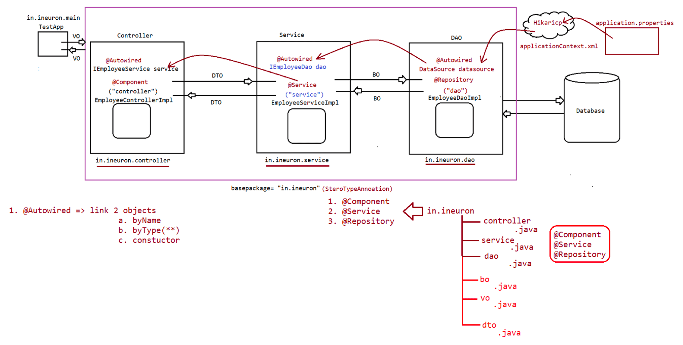

152 Annotations, SpringBean LifeCycle, 100 percent Spring Configuration file, Project on StereoType annotations

List of Annotations used
========================
a. @Component
b. @Service
c. @Repository
d. @Primary
e. @Lazy
f. @Value
g. @PropertySource
h. @Autowired
i. @Qualifier
j. @Required
k. @Scope
l. @Controller
xml
==
<context:component-scan basepackage=""/>
<context:property-placeholder location=''/>
<context:annotation-config/>
SpringBean LifeCycle
====================
1. Java class Life cycle
a. static block
b. instance block
c. constructor
d. setter
e. using the created object,make a call to methods and execute Buisness
logic.
f. Destroy the Object.
2. Spring bean life cycle
***Start the container*******
a. static block
b. object instantiation
c. custom init method(@PostConstruct) if successful then step d,e will
be executed or else it won't execute.
d. Business logic method
e. custom destroy method(@PreDestroy)
***Stop the container********
refer:: IOCProject-27-SpringBeanLifeCycleActionApp
@PostConstruct and @PreDestroy annotations are supplied from jdk, so these
annotations are deprecated in jdk9 and above version, so
to use these annoations in spring framework we need to add a special jar as shown
below.
https://mvnrepository.com/artifact/javax.annotation/javax.annotation-
api/1.3.2
Advantages
==========
1. Makes spring bean as non-invasive.[working to a company without bond]
2. no need to configure spring bean life cycle methods anywhere, based on
annotation automatically they will be executed.
DisAdvantage
===========1. We cannot use this approach for third party supplied pre-defined classes.
100%Code driven SpringApp development/Java Config Approach of SpringApp development
===================================================================================
Advantages
a. XMLBased cfg can be avoided in maximum cases
b. Improves the readability
c. Debugging becomes easy
d. Foundation to learn SpringBoot
ThumbRule
=========
1. Configure userDefined classes as Springbean using Stereotype
annotations(@Component) and link them with Configuration class
alternative to SpringBean cfg file(xml file) using @ComponentScan
note: Java class that is annotated with @Configuration automatically
becomes Configuration class
2. Configure PreDefined class as Spring beans using @Bean methods(method that is
annotated with @Bean) of @Configuration class.
3. use AnnotationConfigApplicationContext class to create an IOC container havaing
@Configuration class as the input classname
Note: @Configuration class is internally a Spring bean becoz @Configuration
internally contains @Component.
AppConfig.java(Alternative to XML)
==================================
package in.ineuron.cfg;
import java.time.LocalDateTime;
import org.springframework.context.annotation.Bean;
import org.springframework.context.annotation.ComponentScan;
import org.springframework.context.annotation.Configuration;
@Configuration
@ComponentScan(basePackages = "in.ineuron")
public class AppConfig {
static {
System.out.println("AppConfig.class file is loading...");
}
public AppConfig() {
constructor...");
}
System.out.println("AppConfig object is created:: Zero param
@Bean(name = "dt")
public LocalDateTime getSysDateTime() {
System.out.println("AppConfig.getSysDateTime()");
LocalDateTime date = LocalDateTime.now();
return date;
}
}Test.java
=========
package in.ineuron.main;
import org.springframework.context.ApplicationContext;
import org.springframework.context.annotation.AnnotationConfigApplicationContext;
import org.springframework.context.support.AbstractApplicationContext;
import in.ineuron.cfg.AppConfig;
import in.ineuron.comp.WishMessageGenerator;
public class TestApp {
public static void main(String[] args)throws Exception {
ApplicationContext factory = new
AnnotationConfigApplicationContext(AppConfig.class);
System.out.println("*****Container started*******\n");
WishMessageGenerator wmg = factory.getBean(WishMessageGenerator.class);
System.out.println(wmg);
String msg = wmg.greetMessage("kohli");
System.out.println(msg);
((AbstractApplicationContext) factory).close();
System.out.println("\n*****Container closed*******");
}
}
Test.java
=========
package in.ineuron.main;
import org.springframework.context.ApplicationContext;
import org.springframework.context.annotation.AnnotationConfigApplicationContext;
import org.springframework.context.support.AbstractApplicationContext;
import in.ineuron.cfg.AppConfig;
import in.ineuron.comp.WishMessageGenerator;
public class TestApp {
public static void main(String[] args)throws Exception {
ApplicationContext factory = new
AnnotationConfigApplicationContext(AppConfig.class);
System.out.println("*****Container started*******\n");
WishMessageGenerator wmg = factory.getBean(WishMessageGenerator.class);
System.out.println(wmg);
String msg = wmg.greetMessage("kohli");
System.out.println(msg);
((AbstractApplicationContext) factory).close();
System.out.println("\n*****Container closed*******");
}}
Usage of @Import(In 100%purejava code configuration)
====================================================
@Import(Resource = {Persistence.class,Service.class,Controller.class})
@Configuration
public class AppConfig{
}
How to load data from properties file into SpringBean?
a. Using application.properties file ====> @PropertyResource(value="location
of properties file") and binding it to @Value("${}") of field
b. Using application.properties file ====> Environment(I) =====> Inside bean
call environment.getProperty("")
refer:: IOCProject-29-RealTimeDI-100%SpringAnnotationsCRUDAPP
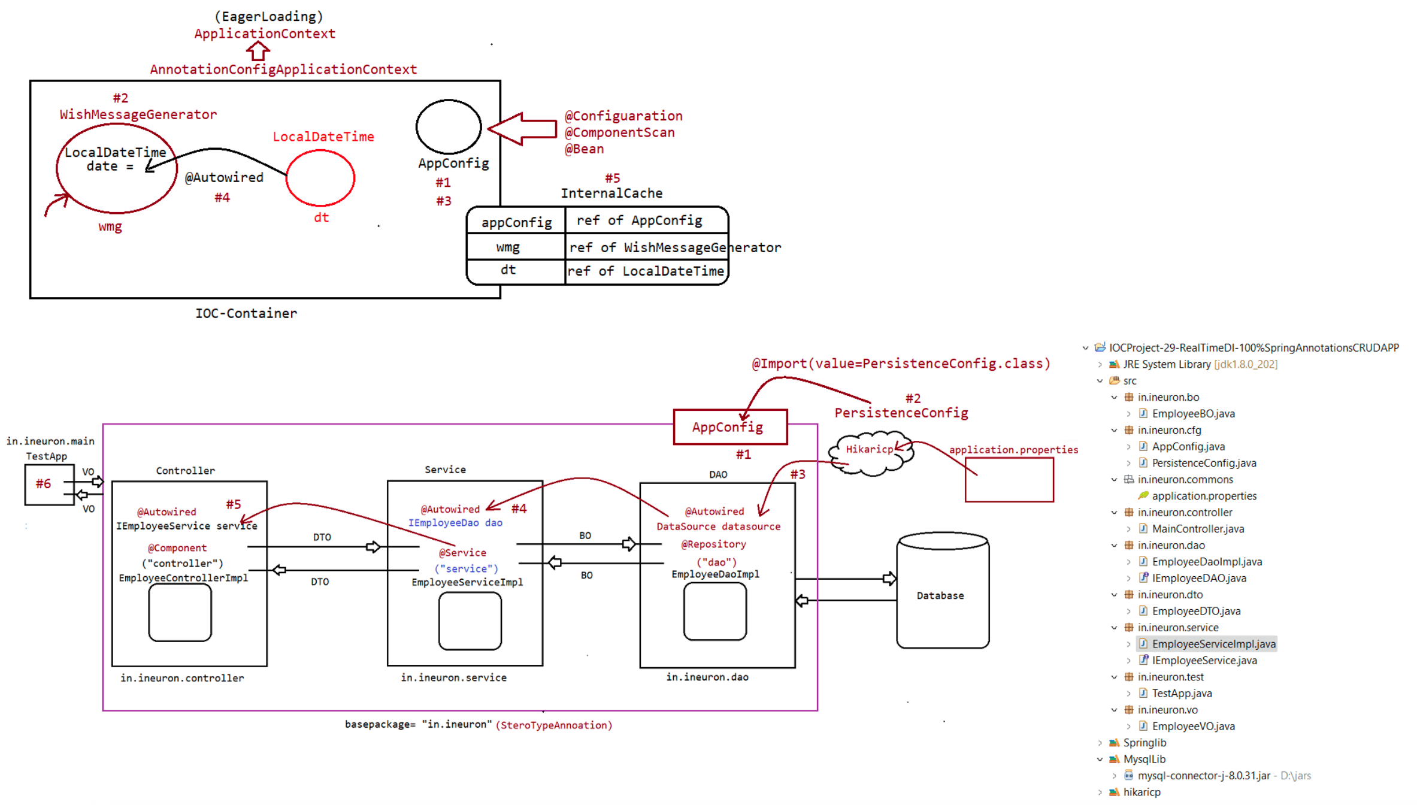
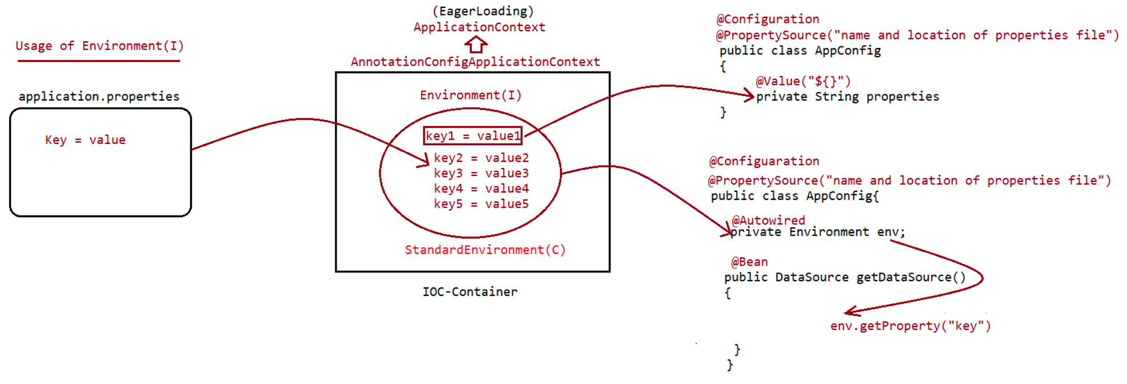

153 introduction to springboot, usage of @SpringBootApplication, installing sts plugin using eclipse, working with spring.io initializer, Basic projects of SpringBoot

List of Annotations
===================
1. @Configuration
2. @ComponentScan
3. @Autowired
4. @Component
5. @Service
6. @Controller(will be used in MVC)
7. @Repository
8. @Import
9. @PropertySource
10.@Bean
11.@Qualifier
12.@Scope
13.@Lazy
14.@Primary
15.@Required
16.@Value
17.@ImportResource
18.@PostContstruct
19.@PreDestroy
100%Code driven SpringApp development/Java Config Approach of SpringApp development
===================================================================================
Advantages
a. XMLBased cfg can be avoided in maximum cases
b. Improves the readability
c. Debugging becomes easy
d. Foundation to learn SpringBoot
ThumbRule
=========
1. Configure userDefined classes as Springbean using Stereotype
annotations(@Component) and link them with Configuration class
alternative to SpringBean cfg file(xml file) using @ComponentScan
note: Java class that is annotated with @Configuration automatically
becomes Configuration class
2. Configure PreDefined class as Spring beans using @Bean methods(method that is
annotated with @Bean) of @Configuration class.
3. use AnnotationConfigApplicationContext class to create an IOC container havaing
@Configuration class as the input classname
Note: @Configuration class is internally a Spring bean becoz @Configuration
internally contains @Component.
ApplicationContext container
----------------------------
1. It is an extension of BeanFactory
2. Implementation classes of ApplicationContext(I)
a. FileSystemXmlApplicationContext(standalone)
b. ClassPathXmlApplicationContext(standalone)
c. XmlWebApplicationContext(SpringMVC apps)
d. AnnotationConfigApplicationContext(Standaloneapp's)
e. AnnotationConfigWebApplicationContext(SpringMVC apps)Configuration of container in purejava style
============================================
@Configuration
@ComponentScan(basePackages={"in.ineuron"})
@Import(value=PersistConfig.class)
public class AppConfig{
}
ClientApp
=========
public class ClientApp{
public static void main(String[] args){
ApplicationContext context = new
AnnotationConfigApplicationContext(AppConfig.class);
}
}
SpringBoot ===> SpringFramework - NoXML +Autoconfiguration(purejavacode)
+EmbededDatabase+EmbededServer+.....
To work with different environments of spring application, spring boot has given
few starters like
a. spring-boot-starter-jdbc
b. spring-boot-starter-mail
c. spring-boot-starter-aop
d. spring-boot-starter-datajpa
e. spring-boot-starter-security
f. spring-boot-starter.mvc
......
SpringBoot
----------
1. These application can be created using
a. STS(SpringToolSuite)
b. Eclipse using STS
c. Spring.io(Intializer)
d. using command line runners
Building application using SpringBoot[eclipse version(2021-03)]
=====================================
Step1:: Keep the following software ready
=> Eclipse IDE with STS plugin(SpringToolSuite)
To install sts plugin :: Help menu-> Eclipse market place -> search for
select all -> click on install->
sts(3.9.14)
accept terms and conditions -> restart IDE.
=>Plugin is a patch software that provides additional features/functionalities to
existing software.
=>STS plugin makes eclipse to develop spring,spring boot apps very easily ... more
over it brings STS IDE features to eclipse IDE.
When we create SpringBoot apps using Spring.io/STS then it would give 3 files
a. MainClass/ConfigurationClass/Starter class.[class with
@SpringBootApplication + main()]
b. application.properties file[src/main/resources]c. pom.xml / build.gradle(build file to build configurations)
@SpringBootApplication
=>@EnableAutoConfiguration(It enables AutoConfiguration)
=>@ComponentScan(Scan for the stereo type annotations in the given package
and subpackage)
=>@Configuration(Marking the class as Configuration class)
=>@PropertySource(location="application.properties")
Need of application.properties
==============================
Using application.properties with predefined keys we do many configurations like
a.DataSourcConfiguration
b.SpringBoot banner configuration
c.SpringSecurity configuration
d.SpringBatch configuration
e.SpringMail configuration
f.InMemoryDB configuration
g. .....
PreDefined keys are available in
https://docs.spring.io/spring-boot/docs/current/reference/html/
SpringApplication.run() internally uses AnnotationConfigApplicationContext class to
create an IOC container by taking java class
as @Configuration class(in fact it takes current class nothing but ClientApp cum
ConfigurationClass)
Note: By default all the components are of Singleton, we can explicitly make it as
other scopes using the anotation called
@Scope(value="")
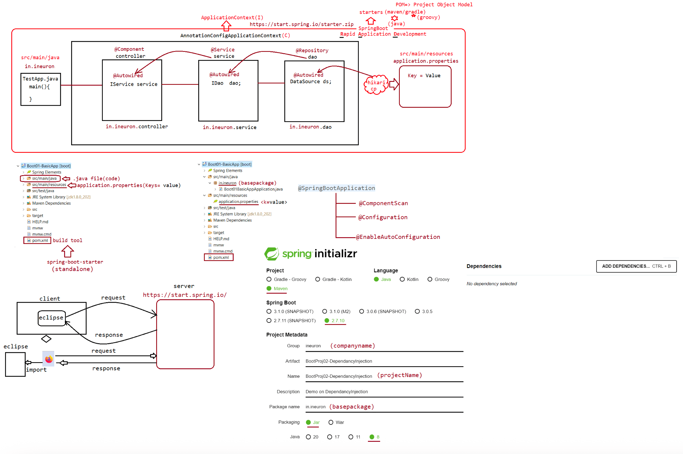

156 SpringBoot @Value vs @ConfigurationProperties, difference b w yml vs properties file , difference b w spring vs springboot, injecting List,Set,Map and HAS A property to springbean.

List of annotations used
========================
1.@Autowired
2.@Component
3.@Service
4.@Repository
5.@Qualifier
6.@Primary
7.@Lazy
8.@PropertySource
9.@Import
10.@ImportResource
12.@ComponentScan
13.@Configuration
14.@Value
15.@Bean
16.@PostConstruct
17.@PreDestroy
================================
1. @SpringBootApplication
|=>@Configuration,@ComponentScan,@EnableAutoConfiguration
Difference b/w Spring vs SpringBoot(interview question)
=======================================================
1. Spring
It is a framework for JEE technologies/Application framework
The main feature is DependancyInjection and DependancyLookUp[JNDI].
It supports XML driven configuration as a inputs to the IOC-Container.
Programmer creates IOC container explicitly.
Allows to devleop spring apps using
a. XML
b. XML + Annotation
c. Pure Java(No XML)
Doesn't give embeded server to use in webapplications.
Doesn't give embeded database/inMemory Database
It is light weight because no autoconfiguration.
No support for "Microservices architecture" based application development.
2. SpringBoot
It provides abstraction for Spring framework and simplifies SpringApp
development.
The main feature is AutoConfiguration(giving common things automatically)
Doesn't support XML driven configuration as a inputs to the IOC-Container.
Programmer doesn't create IOC container explicitly it gets created
automatically using
SpringApplication.run().
Supports only one style of configuration that is AutoConfiguration where
inputs are supplied
through application.properties/.yml file.
It gives embeded server(tomcat server,jetty server) to use in web
applications.
It gives embeded database/InMemory database called "H2".
It is heavy weight because of AutoConfiguration.
Support of Microservices architecture is extensively avilable.
There are 2 different ways to perform injection to spring bean propertiesa. @Value => It can be used to inject each value to spring bean properties
b. @ConfigurationProperties => It can be used to perform bulk injection.
eg:
application.properties
======================
org.info.companyName = ineuron
org.info.companyLoc = bengaluru
org.info.companyType = IT
using @Value
============
@Component("company)
@PropertySource("application.properties")
public class Company{
@Value("${org.info.companyName}")
private String name;
@Value("${org.info.companyLoc}")
private String adress;
@Value("${org.info.copmanyType}")
private String type;
toString()
}
using @ConfigurationProperties
==============================
@Component("company)
@ConfigurationProperites(prefix= "org.info")
public class Company{
private String companyName;
private String companyLoc;
private String companyType;
setXXXX(),toString()
}
What is the difference b/w @Value and @CofigurationProperties?
@Value
=> It is given by Spring framework,so it can be used in Spring and SpringBoot
applications.
=> Support single value injection to Spring bean property.
=> It performs field level injection(setters not required)
=> Common prefix of all keys are not required in
application.properties/application.yml file
=> Keys in properties file and property names need not match.
=> If specified key is not present then it would result in
"IllegalArgumentException".
@Value("${user.info.age}");
syntax:: public int age;
@ConfigurationProperties
applications.
=> It is given by SpringBoot framework,so it can be used only SpringBoot
=> Support bulk operation=> It perform setter level injection internally, so setters are mandatory
=> Common prefix of all keys are required in
application.properties/application.yml file.
=> keys in properties file and property names should match
=> If the matching key is not found then it would neglect the injection.
Note: While working with @ConfigurationProperties, it is always suggested to add
configuarationProcessor inside pom.xml file
<dependency>
<groupId>org.springframework.boot</groupId>
<artifactId>spring-boot-configuration-processor</artifactId>
<optional>true</optional>
</dependency>
Behind the scenes
=================
DAO
===
@Autowired
private DataSource dataSource; //spring-boot-starter-jdbc[hikaricp]
application.properties
======================
spring.datasource.url = jdbc:mysql:///octbatch
spring.datasource.username=root
spring.datasource.password= root123
@ConfigurationProperites(prefix = "spring.datasource")
class .....{
private String url;
private String username;
private String password;
setXXX(),toString()
}
Note:
If we try to inject two different values to same spring bean property using both
@Value and @Configurationproperties, which value will
be injected?
@Value ===> Field injection [ object created, and using reflection api our value
will be set]
@ConfigurationProperties===> Setter Injection[ojbect created,@Value-> field
injection,@ConfigurationProperties->Setterinjection]
Since @ConfigurationProperties performs setter injection, so it overrides the
field injection value given by @Value annotation.
Usage of SPEL in @Value Annotation
==================================
application.properties
----------------------
item.dosa.price = 40
item.idli.price = 20
item.vada.price = 10@Component(value = "info")
public class ItemsInfo {
@Value("${item.idli.price}")
public float idlyPrice;
@Value("${item.vada.price}")
public float vadaPrice;
@Value("${item.dosa.price}")
public float dosaPrice;
}
BillGenerator.class
===================
@Component("bill")
public class BillGenerator {
@Value("#{info.idlyPrice+info.vadaPrice+info.dosaPrice}")
private Float billAmount;//SPEL[SpringExpressionLanguage] is used
@Value("A2B")
private String hotelName;
@Autowired
private ItemsInfo info;
}
Application.java
----------------
package in.ineuron;
import org.springframework.boot.SpringApplication;
import org.springframework.boot.autoconfigure.SpringBootApplication;
import org.springframework.context.ApplicationContext;
import org.springframework.context.ConfigurableApplicationContext;
import in.ineuron.comp.BillGenerator;
@SpringBootApplication
public class Application {
public static void main(String[] args) {
ApplicationContext context = SpringApplication.run(Application.class,
args);
BillGenerator billGenerator = context.getBean(BillGenerator.class);
System.out.println(billGenerator);
((ConfigurableApplicationContext) context).close();
}
}
Output
BillGenerator [billAmount=70.0, hotelName=A2B, info=ItemsInfo [idlyPrice=20.0,
vadaPrice=10.0, dosaPrice=40.0]]
Injection of all types from properties file
===========================================1. Primtive type
2. Array type
3. List type
4. Set type
5. Map type
6. HAS-A type
Injecting values to different types like Arrays,List,Set,Map,HAS-A Property of
SpringBean using Properties/.yml file
===================================================================================
=================================
=> The allowed special characters in properties file is ".","-","[]".
=> To work with Array,List,Set we need to use prefix.<property-
name>[index]=value //index should be sequential
=> To work with Map<K,V> we need to use prefix.<property-name>.<key>=<value>.
Company.java
============
@Component(value = "company")
public class Company {
private String type;
private String location;
private String name;
}
Employee.java
=============
@Component("employee")
@ConfigurationProperties(prefix="emp.info")
public class Employee {
private String name;
private Integer id;
private String[] nickNames;
private List<String> teamMembers;
private Set<Long> phoneNumbers;
private Map<String, Object> idDetails;
@Autowired
private Company company;
}
application.properties
======================
emp.info.name=sachin
emp.info.id=10
#Array properties
emp.info.skills[0] = java
emp.info.skills[1] = jee
emp.info.skills[2] = ORM
emp.info.skills[3] = SpringBoot
#List Properties
emp.info.team-members[0] = sauav
emp.info.team-members[1] = dravid
emp.info.team-members[2] = yuvraj#Set Properties
emp.info.phone-numbers[0]=9998887776
emp.info.phone-numbers[1]=6667778885
emp.info.phone-numbers[2]=4445556667
#Map properties
emp.info.id-details.adharNo= 55566765
emp.info.id-details.panNo= 2321234
emp.info.id-details.voterid= 44323456
#HAS-A properties
emp.info.company.title= PW Skills
emp.info.company.location= Delhi
emp.info.company.size= 5000
Application.java
================
package in.ineuron;
import org.springframework.boot.SpringApplication;
import org.springframework.boot.autoconfigure.SpringBootApplication;
import org.springframework.context.ApplicationContext;
import org.springframework.context.ConfigurableApplicationContext;
import in.ineuron.comp.Employee;
@SpringBootApplication
public class Application {
public static void main(String[] args) {
ApplicationContext context = SpringApplication.run(Application.class,
args);
Employee employee = context.getBean(Employee.class);
System.out.println(employee);
((ConfigurableApplicationContext) context).close();
}
}
output
Employee [name=sachin, id=10,
skills=[java, jee, ORM, SpringBoot],
teamMembers=[sauav, dravid, yuvraj],
phoneNumbers=[9998887776, 6667778885, 4445556667],
idDetails={adharNo=55566765, panNo=2321234, voterid=44323456},
company=Company [title=PW Skills, location=Delhi, size=5000]
]
YML/YAML Injection
==================
=> It stands for Yet Another MarkUp Language
=> The extension of the file is .yml or .yaml
=> The biggest limitation of properties file is nodes/level will be repeated in
mulitple keys,especially while working with
common prefix concepts like collection,HAS-A property to support bulk injection
using @ConfigurationProperties.=> SpringFramework doesnot support yml file/where as SpringBoot support yml
injection
=> SpringBoot framework internally use snakeyml<ver>.jar for processing the yml
file.
application.properties
=====================
emp.info.id=10
emp.info.name=sachin
emp.info.loc=MI
application.yml
==============
emp:
info:
id: 10
name: sachin
loc: MI
Rules while writing yml file
============================
=> same nodes/level in the key should not be duplicated.
=> replace "." of each node/level with ":" and write new node in next line with
proper indentation(minimum single space is required)
=> replace "=" symbol with ":" before placing value having minimum single space.
=> To replace Array,List,Set elements use "-".
=> Take Map collection keys and HAS-A property subkeys as the new nodes/levels.
=> use #symbol for Commenting.
application.yml
===============
#Array properties
emp:
info:
skills:
- java
- jee
- ORM
- SpringBoot
#List Properties
team-members:
- sauav
- dravid
- yuvraj
#Set Properties
phone-numbers:
- 9998887776
- 6667778885
- 4445556667
#Map properties
id-details:
adharNo: 55566765
panNo: 2321234
voterid: 44323456#HAS-A properties
company:
title: PW Skills
location: Delhi
size: 5000
eg#2.
application.properties
======================
spring.datasource.url=jdbc:mysql:///octbatch
spring.datasource.username=root
spring.datasource.password=root123
application.yml
===============
spring:
datasource:
url: jdbc:mysql:///octbatch
username: root
password: root123
=> Once we have properties file in eclipse, we can convert into yml using sts
supplied plugin.
=> The nodes/level in the keys of properties file/.yml file are not case sensitive.
What is the difference b/w properties file and .yml file?
Properties file
==============
=> no rules and guideliness to develop properties file,just Key=Value
=> it can be used only in java
=> No way related to json format
=> can be used in both Spring and SpringBoot project
=> nodes/level in the keys can be duplicated.
=> it is not a hierarchial data
=> Custom properties file can be injected to bean using @PropertySource
=> While working with profiles in springboot we can't place multiple profiles in
single properties file.
=> Spring/SpringBoot directly loads and reads the content of properties file.
=> use properties file when no of keys are minimal and nodes/level in the key are
not duplicated.
YML file
========
=> specification/rule and guideliness given by www.yml.org
=> can be used in .java,.ruby,.python etc
=> Super set of JSON
=> Supported only by SpringBoot
=> nodes/level in the keys can't be duplicated.
=> Its a hierarchial data
=> Custom files will be configured using @PropertySource and specifying
PropertySource class is required.
=> we can place multiple profiles in single yml file having seperation with "--".
=> every yml file will be converted to property files before loading.
=> use yml file when no of keys are more and nodes/level in the key are repeating.

157 Need to project management tool, maven vs ant, life cycle of maven and creating maven projects using CLI, testing the code using Junit

What is build process?
Keeping resources ready=> Arranging them in various folders=> add libraries/jar
to classpath => compilation => execution=> testing
=> packing for release or deployment is continuously required in project
development and delivery process.
Core Java Project build process
===============================
a. develop java resources and other files
b. keep them in different folders
c. add jar files to classpath
d. compilation
e. execution/testing[performing testing on his own piece of code is called
"UnitTesting"]
f. packing the app for release.
Performing build process activities manually is having lots of limitations
a. remembering compilated and repeatitive operations is very tough.
b. we may mismatch order.
c. we may forget certain activities
d. doing multiple activities of build process manually will waste the time.
To automate this process activities we can use .bat file
========================================================
run.bat
=======
cd e:
md xyz
cd xyz
copy ... ...
copy ... ...
set path=...
set classpath = ...
javac -d *.java
java <pkg>.<MainClass>
cmd> run.bat
batch file is given to combine all related commands into single command[by using
single command we can automate the process]
limitations of batch files
==========================
a. Conditional execution is not possible.
b. we can not create dependancy among the operation.
c. jar files must be added dynamically no dynamic downloading of jar file from
internet
d. if one command files is batch file .next command will not execute.
e. It is not declarative[ not self intelligent ie, we need to tell everything to
do]
To overcome some of these problems we got ant tool[Another Neat Tool]
a. It is same as batch files, but we can keep operations as conditional
operations and we can create dependency among
the operations.
To overcome both these tools problem we got "Maven" tools with lots of advanced
features=> Maven is just not a build tool it is also called as "Project Management tool".
KeyFeatures of maven
====================
1. Maven tries to avoid so much configurations as possible by chooosing real
default values and supplying
project templates[archetypes]
2. Can download jars automatically.
3. Can maintatin mulitple repositories having jar files, plugins etc
4. Provides standard project directory structure.
5. Gives maven inheritance to share jar files and plugin among the multiple
projects.
6. Allows to develop multi module projects.
7. Can generate the war,jar,ear file based on the application componenets.
8. Can generate the project documentation.
9. Can run unit tests and can generate unit test reports.
10. Can clean and install the projects in the local servers or remote servers.
Archetypes[Project templates]
=============================
1. maven-archetype-quickstart[for standalone projects]
2. maven-archetype-webapp[for webapplications]
Note: archetypes are project directory structure models
Maven can be build in 2 ways
a. In command line mode
b. From IDE Like Eclipse,Intelij,Netbeans,Eclipselink,....
To keep maven in our system
=================================
a. Download zip file and extract it from the following link
https://maven.apache.org/download.cgi(send one in the link => apache-
maven-3.9.1-bin.zip)
b. Create the following environment variables
a. Add <maven_home>\bin to path environment variables.
set path=D:\jars\apache-maven-3.9.1\bin
b. Add java installation folder to JAVA_HOME environment variables.
set JAVA_HOME=C:\Program Files\Java\jdk1.8.0_202
To check whether maven is installed properly or not just type mvn -version in
command prompt
D:\>mvn -version
Apache Maven 3.9.1 (2e178502fcdbffc201671fb2537d0cb4b4cc58f8)
Maven home: D:\jars\apache-maven-3.9.1
Java version: 1.8.0_202, vendor: Oracle Corporation, runtime: C:\Program Files\
Java\jdk1.8.0_202\jre
Default locale: en_IN, platform encoding: Cp1252
OS name: "windows 10", version: "10.0", arch: "amd64", family: "windows"
Maven repositories
==================
=> Repositories is a small db or folder which holds items.
=> Maven repositories can hold
a. jar files/libraries/dependancies
b. plugins(patch software to provide additional functionalities)
c. old/sample projects[Springboot==> Old project==> inherited through =>
Maveninheritance]In Maven everything (jar/plugin/project) is identified with 3 details[GAV]
a. artifactId(jar file name/plugin name/projectname)
b. groupId(company name)
c. version(jar/plugin/project version)[stable(currently in use),SNAPSHOT(next
version not stable),RELEASE(next version ready)]
eg#1.
GroupId => pivotal team
artifactId => spring-aspects
version => 5.3.17
Repositories
============
a. Central Repositories(given by maven people)
Central Repository:
Avaialble in internet, managed by Apache Maven Community. When Maven does not find
any dependency in local repository, it starts
searching in central repository.
URL for central repository: http://repo.maven.apache.org/maven2
Generally maintains free jars and plugins of open source technologies
b. Local Repositories(In every machine where maven is required)
It is user specific repository, generally it will be collected from TL/PL who
creates Maven project directory structure.
Contains jars, plugins, current project related packings and etc..
Default location: C:\users\<usernmae>\.m2
Will be created automatically for any maven command apart from (mvn -version)
Location can be changed through <maven_home>\conf\settings.xml file using
<localRepository>d:\\maven</localRepository>
c. Remote Repositories(Give by third party companies)
reating an Project using MAVEN in CLI Mode
===========================================
1. Open the Command Prompt and change directory where you want to create your
project and call
mvn archetype:generate (goal to begin the process).
D:\maven>mvn archetype:generate(press enter key)
Choose a number or apply filter (format: [groupId:]artifactId, case sensitive
contains): 2036:
Choose org.apache.maven.archetypes:maven-archetype-quickstart version:
1: 1.0-alpha-1
2: 1.0-alpha-2
3: 1.0-alpha-3
4: 1.0-alpha-4
5: 1.0
6: 1.1
7: 1.3
8: 1.4
Choose a number: 8:
Define value for property 'groupId': ineuron
Define value for property 'artifactId': MathProj1
Define value for property 'version' 1.0-SNAPSHOT: : 1.0
Define value for property 'package' ineuron: : in.ineuron
Confirm properties configuration:
groupId: ineuron
artifactId: MathProj1
version: 1.0package: in.ineuron
Y: :
[INFO] ----------------------------------------------------------------------------
[INFO] Using following parameters for creating project from Archetype: maven-
archetype-quickstart:1.4
[INFO] ----------------------------------------------------------------------------
[INFO] Parameter: groupId, Value: ineuron
[INFO] Parameter: artifactId, Value: MathProj
[INFO] Parameter: version, Value: 1.0
[INFO] Parameter: package, Value: in.ineuron
[INFO] Parameter: packageInPathFormat, Value: in/ineuron
[INFO] Parameter: package, Value: in.ineuron
[INFO] Parameter: version, Value: 1.0
[INFO] Parameter: groupId, Value: ineuron
[INFO] Parameter: artifactId, Value: MathProj
[INFO] Project created from Archetype in dir: D:\Mavenpgms\MathProj1
[INFO] ------------------------------------------------------------------------
[INFO] BUILD SUCCESS
[INFO] ------------------------------------------------------------------------
[INFO] Total time: 05:18 min
[INFO] Finished at: 2023-04-03T12:35:58+05:30
[INFO] ------------------------------------------------------------------------
MathProj1
|=> src/main/java[source code]
|=> in.ineuron
|=> MathApp.java(source code)
|=> src/test/java[test code-> unit testing]
|=> in.ineuron
|=> AppTest.java(test code)
|=> pom.xml(build file)===> groupId,artifactId,version
MathApp.java
============
package in.ineuron;
public class MathApp {
public int add(int x, int y){
return x+y;
}
public static void main( String[] args ){
MathApp m = new MathApp();
int result = m.add(10,20);
System.out.println("The sum is :: "+result);
}
}
In the command prompt execute the following life cycle actions
a. mvn package
>» Generates jar files in target folder having <projectname>-ver. jar file
b. mvn clean
c. mvn clean package
» Cleans the project .. deletes target folder
» Cleans the project and also creates jar file with latest code
d. mvn compile
>> compile the project code and generate the .class file in target folder.
To run jar file App manuallyD:\mavenpgms\MathProjl>java -cp target/MathProj1-1.0.jar
in.ineuron.Arithmetic
The Maven Life cycles are
a. clean(3 phases)
b. default(23 phases)
c. site (4 phases)
=> Each life cycle of maven will have lot of phases.
=> These phases are already linked with plugins to peform certain operations, but
we can configure extra plugins to perform
more operations.
To test our code writing unit test case through Junit
=====================================================
package in.ineuron;
import junit.framework.*;
import in.ineuron.*;
public class AppTest extends TestCase{
public void testSumWithPositiveNumber(){
MathApp ar = new MathApp();
int actual = ar.add(10,20);
int expected = 30;
assertEquals(actual,expected);
}
public void testSumWithNegativeNumber(){
MathApp ar = new MathApp();
int actual = ar.add(-10,-20);
int expected = -30;
assertEquals(actual,expected);
}
public void testSumWithMixedNumber(){
MathApp ar = new MathApp();
int actual = ar.add(-10,20);
int expected = 10;
assertEquals(actual,expected);
}
public void testSumWithZero(){
MathApp ar = new MathApp();
int actual = ar.add(0,0);
int expected = 0;
assertEquals(actual,expected);
}
}
D:\Mavenpgms\MathProj1>mvn test
=> runs all the test cases and generates the
report in command line.
D:\Mavenpgms\MathProj1>mvn surefire-report:report
=> go to target folder search for a file called
surefire-report.html
D:\Mavenpgms\MathProj1>mvn site
=> go to target folder search for a file called
index.html
Maven can't execute the java app directly becoz there is no life cycle phases for
that.
<build>
<plugins>
To use that we need to use an extra plugin called :: exec-maven-plugin<plugin>
<groupId>org.codehaus.mojo</groupId>
<artifactId>exec-maven-plugin</artifactId>
<version>3.1.0</version>
<executions>
<execution>
<id>ArithmeticApp</id>
<phase>package</phase>
<goals>
<goal>java</goal>
</goals>
</execution>
</executions>
<configuration>
<mainClass>in.ineuron.MathApp</mainClass>
</configuration>
</plugin>
</plugins>
</build>
D:\Mavenpgms\MathProj1>mvn clean package
[INFO] Scanning for projects...
[INFO]
[INFO] -------------------------< ineuron:MathProj1 >--------------------------
[INFO] Building MathProj1 1.0
[INFO] from pom.xml
[INFO] --------------------------------[ jar ]---------------------------------
[INFO]
[INFO] --- clean:3.2.0:clean (default-clean) @ MathProj1 ---
[INFO] Deleting D:\Mavenpgms\MathProj1\target
[INFO]
[INFO] --- resources:3.3.0:resources (default-resources) @ MathProj1 ---
[WARNING] Using platform encoding (Cp1252 actually) to copy filtered resources,
i.e. build is platform dependent!
[INFO] skip non existing resourceDirectory D:\Mavenpgms\MathProj1\src\main\
resources
[INFO]
[INFO] --- compiler:3.10.1:compile (default-compile) @ MathProj1 ---
[INFO] Changes detected - recompiling the module!
[WARNING] File encoding has not been set, using platform encoding Cp1252, i.e.
build is platform dependent!
[INFO] Compiling 1 source file to D:\Mavenpgms\MathProj1\target\classes
[INFO]
[INFO] --- resources:3.3.0:testResources (default-testResources) @ MathProj1 ---
[WARNING] Using platform encoding (Cp1252 actually) to copy filtered resources,
i.e. build is platform dependent!
[INFO] skip non existing resourceDirectory D:\Mavenpgms\MathProj1\src\test\
resources
[INFO]
[INFO] --- compiler:3.10.1:testCompile (default-testCompile) @ MathProj1 ---
[INFO] Changes detected - recompiling the module!
[WARNING] File encoding has not been set, using platform encoding Cp1252, i.e.
build is platform dependent!
[INFO] Compiling 1 source file to D:\Mavenpgms\MathProj1\target\test-classes
[INFO]
[INFO] --- surefire:3.0.0:test (default-test) @ MathProj1 ---
[INFO] Using auto detected provider org.apache.maven.surefire.junit.JUnit3Provider
[INFO][INFO] -------------------------------------------------------
[INFO] T E S T S
[INFO] -------------------------------------------------------
[INFO] Running in.ineuron.AppTest
[INFO] Tests run: 4, Failures: 0, Errors: 0, Skipped: 0, Time elapsed: 0.011 s - in
in.ineuron.AppTest
[INFO]
[INFO] Results:
[INFO]
[INFO] Tests run: 4, Failures: 0, Errors: 0, Skipped: 0
[INFO]
[INFO]
[INFO] --- jar:3.3.0:jar (default-jar) @ MathProj1 ---
[INFO] Building jar: D:\Mavenpgms\MathProj1\target\MathProj1-1.0.jar
[INFO]
[INFO] --- exec:3.1.0:java (ArithmeticOperation) @ MathProj1 ---
The sum is :: 300
[INFO] ------------------------------------------------------------------------
[INFO] BUILD SUCCESS
[INFO] ------------------------------------------------------------------------
[INFO] Total time: 4.162 s
[INFO] Finished at: 2023-04-04T22:59:06+05:30
[INFO] ------------------------------------------------------------------------
D:\Mavenpgms\MathProj1>java -cp target\MathProj1-1.0.jar in.ineuron.MathApp
The sum is :: 300

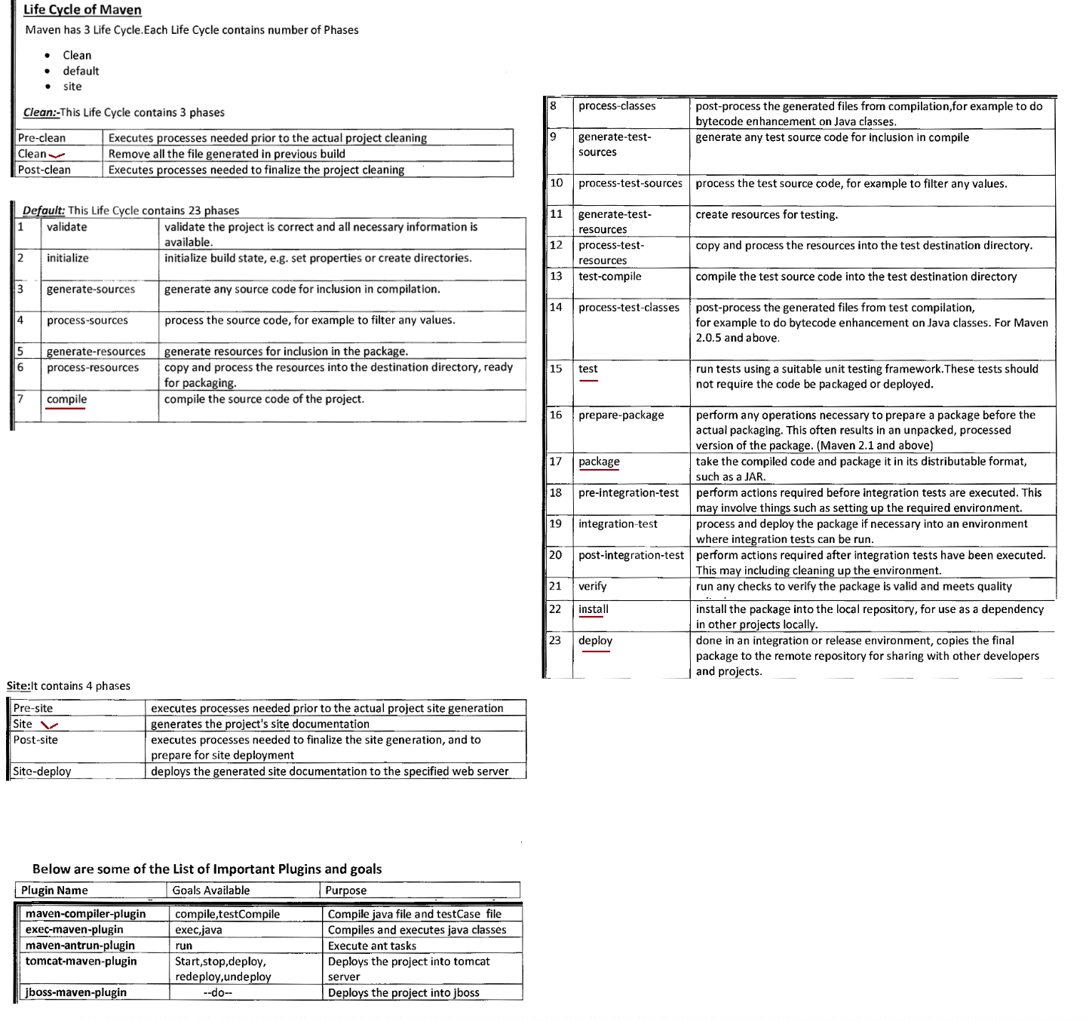

159 Usage of repositories, maven inheritance, Working with local,central,remote repositories, Creating standalone project in maven for jdbc,hibernate.

Creating a standalone maven project in Non-Interactive Mode
===========================================================
-DgroupId=ineuron
-Dartifactlid=SwapDemoCmd
-DarchetypeArtifactid=maven-archetype-quickstart
-DinteractiveMode=false
D:\mavenpgms\>mvn archetype:generate -DgroupId=ineuron -DartifactId=SwapDemoApp -
DarchetypeArtifactId=maven-archetype-quickstart
-Dpackage=in.ineuron -Dversion=1.0 -DinteractiveMode=false
SwapDemoApp
src/main/java
src/main/test
|=> in.ineuron.SwapDemoApp(main method)
|=> in.ineuron.App(test case code)
package in.ineuron;
class SwapApp
{
int a,b;
public void accept(int x,int y){
a=x;
b=y;
}
public void swapValues(){
a=a+b;
b=a-b;
a=a-b;
}
void disp(){
System.out.println("Value of a is :: "+a);
System.out.println("Value of b is :: "+b);
}
}
public class SwapDemoApp {
public static void main( String[] args ){
if(args.length!=2)
System.out.println("Plz enter 2 numbers...");
else{
int x1= Integer.parseInt(args[0]);
int x2= Integer.parseInt(args[1]);
SwapApp s = new SwapApp();
s.accept(x1,x2);
System.out.println("Before swapping");
System.out.println("---------------");
s.disp();
s.swapValues();
System.out.println("After swapping");
System.out.println("---------------");
s.disp();
}
}
}
pom.xml[The above program should run from maven and it should accept command line
arguments,so we use a plugin called "exec-maven-plugin"]=======
<build>
<plugins>
<plugin>
<groupId>org.codehaus.mojo</groupId>
<artifactId>exec-maven-plugin</artifactId>
<version>3.1.0</version>
<executions>
<execution>
<id>ex2</id>
<phase>package</phase>
<goals>
<goal>java</goal>
</goals>
</execution>
</executions>
<configuration>
<mainClass>in.ineuron.SwapDemoApp</mainClass>
<arguments>
<argument>30</argument>
<argument>40</argument>
</arguments>
</configuration>
</plugin>
</plugins>
</build>
D:\Mavenpgms\SwapDemoApp>mvn package
[INFO] Scanning for projects...
[INFO]
[INFO] ------------------------< ineuron:SwapDemoApp >-------------------------
[INFO] Building SwapDemoApp 1.1
[INFO] from pom.xml
[INFO] --------------------------------[ jar ]---------------------------------
[INFO]
[INFO] --- resources:3.3.0:resources (default-resources) @ SwapDemoApp ---
[WARNING] Using platform encoding (Cp1252 actually) to copy filtered resources,
i.e. build is platform dependent!
[INFO] skip non existing resourceDirectory D:\Mavenpgms\SwapDemoApp\src\main\
resources
[INFO]
[INFO] --- compiler:3.10.1:compile (default-compile) @ SwapDemoApp ---
[INFO] Changes detected - recompiling the module!
[WARNING] File encoding has not been set, using platform encoding Cp1252, i.e.
build is platform dependent!
[INFO] Compiling 1 source file to D:\Mavenpgms\SwapDemoApp\target\classes
[INFO]
[INFO] --- resources:3.3.0:testResources (default-testResources) @ SwapDemoApp ---
[WARNING] Using platform encoding (Cp1252 actually) to copy filtered resources,
i.e. build is platform dependent!
[INFO] skip non existing resourceDirectory D:\Mavenpgms\SwapDemoApp\src\test\
resources
[INFO]
[INFO] --- compiler:3.10.1:testCompile (default-testCompile) @ SwapDemoApp ---
[INFO] Changes detected - recompiling the module!
[WARNING] File encoding has not been set, using platform encoding Cp1252, i.e.
build is platform dependent!
[INFO] Compiling 1 source file to D:\Mavenpgms\SwapDemoApp\target\test-classes
[INFO][INFO] --- surefire:3.0.0:test (default-test) @ SwapDemoApp ---
[INFO] Using auto detected provider org.apache.maven.surefire.junit.JUnit3Provider
[INFO]
[INFO] -------------------------------------------------------
[INFO] T E S T S
[INFO] -------------------------------------------------------
[INFO] Running in.ineuron.AppTest
[INFO] Tests run: 1, Failures: 0, Errors: 0, Skipped: 0, Time elapsed: 0.01 s - in
in.ineuron.AppTest
[INFO]
[INFO] Results:
[INFO]
[INFO] Tests run: 1, Failures: 0, Errors: 0, Skipped: 0
[INFO]
[INFO]
[INFO] --- jar:3.3.0:jar (default-jar) @ SwapDemoApp ---
[INFO] Building jar: D:\Mavenpgms\SwapDemoApp\target\SwapDemoApp-1.1.jar
[INFO]
[INFO] --- exec:3.1.0:java (Swap2NumbersApp) @ SwapDemoApp ---
Before swapping
---------------
Value of a is :: 30
Value of b is :: 40
After swapping
---------------
Value of a is :: 40
Value of b is :: 30
[INFO] ------------------------------------------------------------------------
[INFO] BUILD SUCCESS
[INFO] ------------------------------------------------------------------------
[INFO] Total time: 4.270 s
[INFO] Finished at: 2023-04-05T20:07:36+05:30
[INFO] ------------------------------------------------------------------------
Working in eclipse to create a maven standalone project
=======================================================
Maven Project
=> Dont select checkbox create a simple project
=> Choose archetype as
maven-archetype-quickstart (select version-1.4 from org.apache.maven)
=> provide
groupid : pwskills
artifactid: MavenProject1
version : 1.0
MavenProject1
|=> src/main/java
|=> in.pwskills.JdbcSelectApp(main code)
|=> src/main/test
|=> in.pwskills.AppTest.java
|=> pom.xml(mysql-connectector-java.jar)
JdbcSelectApp.java
==================
package in.pwskills;
import java.sql.Connection;import java.sql.DriverManager;
import java.sql.ResultSet;
import java.sql.Statement;
public class JdbcSelectApp {
public static void main(String[] args) throws Exception {
String url = "jdbc:mysql://localhost:3306/octbatch";
String username = "root";
String password = "root123";
Connection connection = DriverManager.getConnection(url, username,
password);
System.out.println("Connection object is created:: " + connection);
Statement statement = connection.createStatement();
System.out.println("Statement object is created:: " + statement);
String sqlSelectQuery = "SELECT SID,SNAME,SAGE,SADDRESS FROM STUDENT";
ResultSet resultSet = statement.executeQuery(sqlSelectQuery);
System.out.println("ResultSet object is created:: " + resultSet);
System.out.println("SID\tSNAME\tSAGE\tSADDR");
while (resultSet.next()) {
Integer id = resultSet.getInt(1);
String name = resultSet.getString(2);
Integer age = resultSet.getInt(3);
String team = resultSet.getString(4);
System.out.println(id + "\t" + name + "\t" + age + "\t" + team);
}
// Close the Connection
connection.close();
System.out.println("Closing the connection...");
}
}
pom.xml
=======
<?xml version="1.0" encoding="UTF-8"?>
<project xmlns="http://maven.apache.org/POM/4.0.0"
xmlns:xsi="http://www.w3.org/2001/XMLSchema-instance"
xsi:schemaLocation="http://maven.apache.org/POM/4.0.0
http://maven.apache.org/xsd/maven-4.0.0.xsd">
<modelVersion>4.0.0</modelVersion>
<groupId>pwskills</groupId>
<artifactId>MavenProj1</artifactId>
<version>1.2</version>
<name>MavenProj1</name>
<!-- FIXME change it to the project's website -->
<url>http://www.example.com</url>
<properties>
<project.build.sourceEncoding>UTF-8</project.build.sourceEncoding>
<maven.compiler.source>1.8</maven.compiler.source><maven.compiler.target>1.8</maven.compiler.target>
</properties>
<dependencies>
<dependency>
<groupId>junit</groupId>
<artifactId>junit</artifactId>
<version>4.11</version>
<scope>test</scope>
</dependency>
<!-- https://mvnrepository.com/artifact/com.mysql/mysql-connector-j -->
<dependency>
<groupId>com.mysql</groupId>
<artifactId>mysql-connector-j</artifactId>
<version>8.0.31</version>
</dependency>
</dependencies>
<build>
<pluginManagement><!-- lock down plugins versions to avoid using Maven defaults
(may be moved to parent pom) -->
<plugins>
<!-- Executing maven as java program-->
<plugin>
<groupId>org.codehaus.mojo</groupId>
<artifactId>exec-maven-plugin</artifactId>
<version>3.1.0</version>
<executions>
<execution>
<id>JDBCSELECT APP</id>
<phase>package</phase>
<goals>
<goal>java</goal>
</goals>
</execution>
</executions>
<configuration>
<mainClass>in.pwskills.JdbcSelectApp</mainClass>
</configuration>
</plugin>
</plugins>
</pluginManagement>
</build>
</project>
Execution
=========
on run
right click on project-> run=> maven build => type in goals as exec:java and click
output
======
Connection object is created:: com.mysql.cj.jdbc.ConnectionImpl@707f21d6
Statement object is created:: com.mysql.cj.jdbc.StatementImpl@518376cd
ResultSet object is created:: com.mysql.cj.jdbc.result.ResultSetImpl@20117d95
SID SNAME SAGE SADDR
7 dhoni 41 CSK10 sachin 49 MI
18 kohli 36 RCB
33 pandya 31 GT
99 rahul 31 LSG
Closing the connection...
Maven features
==============
1. properties
In pom.xml file we use properties feature to link to the version of Spring module
version
<properties>
<project.build.sourceEncoding>UTF-8</project.build.sourceEncoding>
<maven.compiler.source>1.8</maven.compiler.source>
<maven.compiler.target>1.8</maven.compiler.target>
<spring.version>5.3.26</spring.version>
</properties>
<dependencies>
<dependency>
<groupId>org.springframework</groupId>
<artifactId>spring-context</artifactId>
<version>${spring.version}</version>
</dependency>
<!-- https://mvnrepository.com/artifact/org.springframework/spring-jdbc -->
<dependency>
<groupId>org.springframework</groupId>
<artifactId>spring-jdbc</artifactId>
<version>${spring.version}</version>
</dependency>
<!-- https://mvnrepository.com/artifact/org.springframework/spring-orm -->
<dependency>
<groupId>org.springframework</groupId>
<artifactId>spring-orm</artifactId>
<version>${spring.version}</version>
</dependency>
<!-- https://mvnrepository.com/artifact/org.springframework/spring-webmvc -->
<dependency>
<groupId>org.springframework</groupId>
<artifactId>spring-webmvc</artifactId>
<version>${spring.version}</version>
</dependency>
</dependencies>
2. exclusion
In pom.xml file we can use exclusion to exclude particular dependant jar without
excluding a main jar
<dependency>
<groupId>org.hibernate</groupId>
<artifactId>hibernate-core</artifactId>
<version>5.6.15.Final</version>
<exclusions>
<exclusion>
<groupId>org.jboss.logging</groupId>
<artifactId>jboss-logging</artifactId></exclusion>
</exclusions>
</dependency>
Working with repositories
=========================
1. local repository
2. central repository
3. remote repository
refer: MavenProj1
pom.xml(mysqlconnector from central repository)
===============================================
<!-- https://mvnrepository.com/artifact/com.mysql/mysql-connector-j -->
<dependency>
<groupId>com.mysql</groupId>
<artifactId>mysql-connector-j</artifactId>
<version>8.0.32</version>
</dependency>
pom.xml(oracleconnector from central repository)
================================================
<!-- https://mvnrepository.com/artifact/com.oracle.database.jdbc/ojdbc8 -->
<dependency>
<groupId>com.oracle.database.jdbc</groupId>
<artifactId>ojdbc8</artifactId>
<version>19.12.0.0</version>
</dependency>
pom.xml(oracleconnector from remote repository)
================================================
<!-- https://mvnrepository.com/artifact/com.oracle.jdbc/ojdbc8 -->
<dependency>
<groupId>com.oracle.jdbc</groupId>
<artifactId>ojdbc8</artifactId>
<version>12.2.0.1</version>
</dependency>
<repositories>
<repository>
<id>sample</id>
<url>https://broadinstitute.jfrog.io/artifactory/libs-release-local/</
url>
</repository>
</repositories>
Creating a local repository in .m2 folder for oracle jar
=======================================================
D:\Mavenpgms\SwapDemoApp>mvn install:install-file -Dfile=C:\oraclexe\app\oracle\
product\11.2.0\server\jdbc\lib\ojdbc6.jar -DgroupId=nitinineuron -
DartifactId=nitinineuronoracleljar -Dversion=11.2 -Dpackaging=jar
[INFO] Scanning for projects...
[INFO]
[INFO] ------------------------< ineuron:SwapDemoApp >-------------------------
[INFO] Building SwapDemoApp 1.1
[INFO] from pom.xml[INFO] --------------------------------[ jar ]---------------------------------
[INFO]
[INFO] --- install:3.1.0:install-file (default-cli) @ SwapDemoApp ---
[INFO] pom.xml not found in ojdbc6.jar
[INFO] Installing C:\oraclexe\app\oracle\product\11.2.0\server\jdbc\lib\ojdbc6.jar
to C:\Users\nitin\.m2\repository\nitinineuron\nitinineuronoracleljar\11.2\
nitinineuronoracleljar-11.2.jar
[INFO] Installing C:\Users\nitin\AppData\Local\Temp\
mvninstall5098441414756102901.pom to C:\Users\nitin\.m2\repository\nitinineuron\
nitinineuronoracleljar\11.2\nitinineuronoracleljar-11.2.pom
[INFO] ------------------------------------------------------------------------
[INFO] BUILD SUCCESS
[INFO] ------------------------------------------------------------------------
[INFO] Total time: 1.320 s
[INFO] Finished at: 2023-04-05T22:10:27+05:30
[INFO] ------------------------------------------------------------------------
In our project pom.xml file we need to use
==========================================
<dependency>
<groupId>nitinineuron</groupId>
<artifactId>nitinineuronoracleljar</artifactId>
<version>11.2</version>
</dependency>
Maven Inheritance
==================
In one project pom.xml, we can add <parent> tag having other project info like
<groupld>, <artifactld> and <version> to get
other project dependencies and plugins.
=> Create one project called HBProj-01 it will have groupId,artifactId,version
pom.xml
=======
<groupId>pwskills</groupId>
<artifactId>HBproj-01</artifactld>
<version>1.1</version>
<properties>
<project.build.sourceEncoding>UTF-8</project.build.sourceEncoding>
<maven.compiler.source>1.8</maven.compiler.source>
<maven.compiler.target>1.8</maven.compiler.target>
<hibernate-version>5.6.15.Final</hibernate-version>
<mysql-version>8.0.32</mysql-version>
</properties>
<dependencies>
<dependency>
<groupId>junit</groupId>
<artifactId>junit</artifactId>
<version>4.11</version>
<scope>test</scope>
</dependency>
<!-- https://mvnrepository.com/artifact/org.hibernate/hibernate-core -->
<dependency>
<groupId>org.hibernate</groupId>
<artifactId>hibernate-core</artifactId><version>${hibernate-version}</version>
</dependency>
<!-- https://mvnrepository.com/artifact/com.mysql/mysql-connector-j -->
<dependency>
<groupId>com.mysql</groupId>
<artifactId>mysql-connector-j</artifactId>
<version>${mysql-version}</version>
</dependency>
</dependencies>
=> Create one more project called HBProj-02(child project)
pom.xml
=======
<parent>
<groupId>iNeuron</groupId>
<artifactId>HBproj-02</artifactld>
<version>1.2</version>
</parent>
refer: Hibernate-01, Hiberante-02
To see the nature of inheritance check for Hibernate-02 dependancies
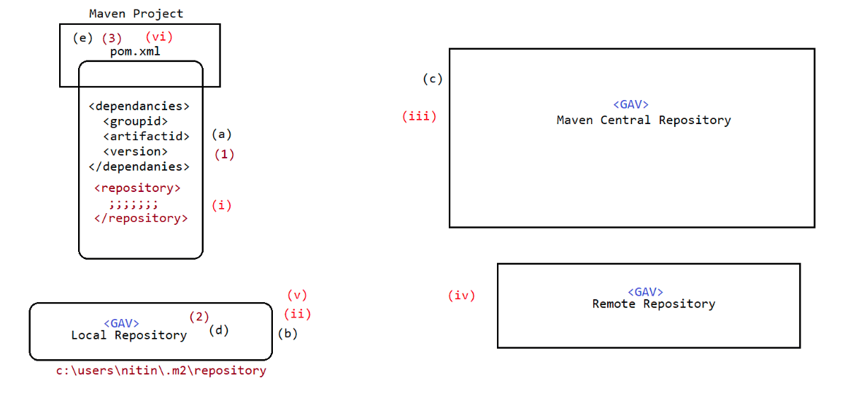

160 Maven for webapps,creating war and deploying manually, maven performing smooth deployment, Creating maven project for working with Servlet,JSP,Hibernate,JDBC,JSTL

Maven for webapps
=================
archetype => maven-archetype-webapp
zipping => war
Creating a maven project for webapplications
============================================
mvn archetype:generate -DgroupId=ineuron -DartifactId=WishApp -Dversion=1.0 -
DarchetypeArtifactId=maven-archetype-webapp
-DinteractiveMode=false -Dpackaging=war -
Dpackage=in.ineuron.controller
Directory structure
===================
WishApp
|
src/main/java(folder should be created manually)
|=> in.ineuron.controller.WishServlet.java(servlet)
src/main/resources(empty folder without any file)
src/main/webapp
|=> WEB-INF
|=> web.xml
|=> index.jsp(UI)
pom.xml
|=> servlet-api.jar
WishServlet.java
===============
package in.ineuron.controller;
import java.io.IOException;
import java.io.PrintWriter;
import java.time.LocalDateTime;
import javax.servlet.ServletException;
import javax.servlet.annotation.WebServlet;
import javax.servlet.http.HttpServlet;
import javax.servlet.http.HttpServletRequest;
import javax.servlet.http.HttpServletResponse;
@WebServlet("/wish")
public class WishServlet extends HttpServlet {
private static final long serialVersionUID = 1L;
@Override
public void doGet(HttpServletRequest request, HttpServletResponse response)
throws ServletException, IOException {
response.setContentType("text/html");
PrintWriter pw = response.getWriter();
LocalDateTime dt = LocalDateTime.now();
int hour = dt.getHour();
pw.println("<h1><center>Today date and time is :: " + dt +
"</center></h1>");
if (hour < 12)pw.println("<h2><center>Good Morning </center></h2>");
else if (hour < 16)
else if (hour < 20)
pw.println("<h2><center>Good Afternoon</center></h2>");
pw.println("<h2><center>Good Evening</center></h2>");
else
pw.println("<h2><center>Good night</center></h2>");
pw.close();
}
@Override
public void doPost(HttpServletRequest request, HttpServletResponse response)
throws ServletException, IOException {
doGet(request, response);
}
}
pom.xml
=======
<dependencies>
<dependency>
<groupId>javax.servlet</groupId>
<artifactId>javax.servlet-api</artifactId>
<version>3.0.1</version>
<scope>provided</scope>
</dependency>
</dependencies>
index.jsp
=========
<html>
<body>
<h1 style='color:blue;text-align:center;'>HTML 2 SERVLET COMMUNICATION</h1>
<h2 style='color:red; text-align: center;'>
<a href='./wish'>Generate Wish Message</a>
</h2>
</body>
</html>
D:\Mavenpgms\WishApp>mvn package
[INFO] Scanning for projects...
[INFO]
[INFO] --------------------------< iNeuron:WishApp >---------------------------
[INFO] Building WishApp Maven Webapp 1.0
[INFO] from pom.xml
[INFO] --------------------------------[ war ]---------------------------------
[INFO]
[INFO] --- resources:3.3.0:resources (default-resources) @ WishApp ---
[WARNING] Using platform encoding (Cp1252 actually) to copy filtered resources,
i.e. build is platform dependent!
[INFO] Copying 0 resource
[INFO]
[INFO] --- compiler:3.10.1:compile (default-compile) @ WishApp ---
[INFO] Changes detected - recompiling the module!
[WARNING] File encoding has not been set, using platform encoding Cp1252, i.e.
build is platform dependent!
[INFO] Compiling 1 source file to D:\Mavenpgms\WishApp\target\classes
[INFO][INFO] --- resources:3.3.0:testResources (default-testResources) @ WishApp ---
[WARNING] Using platform encoding (Cp1252 actually) to copy filtered resources,
i.e. build is platform dependent!
[INFO] skip non existing resourceDirectory D:\Mavenpgms\WishApp\src\test\resources
[INFO]
[INFO] --- compiler:3.10.1:testCompile (default-testCompile) @ WishApp ---
[INFO] No sources to compile
[INFO]
[INFO] --- surefire:3.0.0:test (default-test) @ WishApp ---
[INFO] No tests to run.
[INFO]
[INFO] --- war:3.3.2:war (default-war) @ WishApp ---
[INFO] Packaging webapp
[INFO] Assembling webapp [WishApp] in [D:\Mavenpgms\WishApp\target\WishApp]
[INFO] Processing war project
[INFO] Copying webapp resources [D:\Mavenpgms\WishApp\src\main\webapp]
[INFO] Building war: D:\Mavenpgms\WishApp\target\WishApp.war
[INFO] ------------------------------------------------------------------------
[INFO] BUILD SUCCESS
[INFO] ------------------------------------------------------------------------
[INFO] Total time: 3.516 s
[INFO] Finished at: 2023-04-06T20:09:26+05:30
[INFO] ------------------------------------------------------------------------
Note:gives war file copy that war file to webapps folder of tomcat server(HARD
deployment)
=>run tomcat and send the request to check the response
http://localhost:9999/WishApp
Usage of one Maven project code in another Maven project code
=============================================================
mvn install => it creates the jar for the entire class and keeping the jar file in
the local repository.
[under .m2 folder-->check for groupId]
D:\Mavenpgms\MathProj2>mvn tomcat7:run
|=> MathProj2 will be installed as jar file in .m2
repository with [GAV]
pom.xml
=======
<project xmlns="http://maven.apache.org/POM/4.0.0"
xmlns:xsi="http://www.w3.org/2001/XMLSchema-instance"
xsi:schemaLocation="http://maven.apache.org/POM/4.0.0
http://maven.apache.org/maven-v4_0_0.xsd">
<modelVersion>4.0.0</modelVersion>
<groupId>ineuron</groupId>
<artifactId>WishMsgApp</artifactId>
<packaging>war</packaging>
<version>1.0-SNAPSHOT</version>
<name>WishMsgApp Maven Webapp</name>
<url>http://maven.apache.org</url>
<dependencies>
<dependency>
<groupId>junit</groupId>
<artifactId>junit</artifactId>
<version>3.8.1</version>
<scope>test</scope></dependency>
<dependency>
<groupId>javax.servlet</groupId>
<artifactId>javax.servlet-api</artifactId>
<version>3.0.1</version>
<scope>provided</scope>
</dependency>
<!-- Our project jar---->
<dependency>
<groupId>ineuron</groupId>
<artifactId>MathProj</artifactId>
<version>1.0</version>
</dependency>
</dependencies>
<!-- build for maven plugin to deploy our project---->
<build>
<finalName>WishMsgApp</finalName>
<plugins>
<plugin>
<groupId>org.apache.tomcat.maven</groupId>
<artifactId>tomcat7-maven-plugin</artifactId>
<version>2.1</version>
<configuration>
<server>tomcat</server>
<url>http://localhost:2020/manager</url>
<path>/WishMsgApp</path>
<port>9999</port>
</configuration>
</plugin>
</plugins>
</build>
</project>
WishServlet.java
===============
package in.ineuron.controller;
import java.io.IOException;
import java.io.PrintWriter;
import java.time.LocalDateTime;
import in.ineuron.Arithmetic;//import the other project class(coming from local
repository jar)
import javax.servlet.ServletException;
import javax.servlet.annotation.WebServlet;
import javax.servlet.http.HttpServlet;
import javax.servlet.http.HttpServletRequest;
import javax.servlet.http.HttpServletResponse;
@WebServlet("/wish")
public class WishServlet extends HttpServlet {
private static final long serialVersionUID = 1L;
@Override
public void doGet(HttpServletRequest request, HttpServletResponse response)throws ServletException, IOException {
response.setContentType("text/html");
PrintWriter pw = response.getWriter();
LocalDateTime dt = LocalDateTime.now();
int hour = dt.getHour();
//usage of local repository jar class
Arithmetic ar = new Arithmetic();
int sum = ar.add(10,20);
pw.println("<h1><center>Today date and time is :: " + dt +
"</center></h1>");
if (hour < 12)
else if (hour < 16)
else if (hour < 20)
pw.println("<h2><center>Good Morning </center></h2>");
pw.println("<h2><center>Good Afternoon</center></h2>");
pw.println("<h2><center>Good Evening</center></h2>");
else
pw.println("<h2><center>Good night</center></h2>");
pw.println("<h1 style='color:red;'><center>The sum is ::
"+sum+"</center></h1>");
pw.close();
}
@Override
public void doPost(HttpServletRequest request, HttpServletResponse response)
throws ServletException, IOException {
doGet(request, response);
}
}
cmd> mvn tomcat7:run
open browser and send the request
http://localhost:9999/WishMsgApp/
Test the App with this url: http://localhost:9999/WishMsgApp/
Commands to manipulate WAR file on Tomcat.
» mvn tomcat7:deploy //deployment
» mvn tomcat7:undeploy //undeployment
» mvn tomcat7:redeploy //redeployment
List out the dependency scope in Maven?
The various dependency scope used in Maven are:
Compile: It is the default scope, and it indicates what dependency is available in
the classpath of the project
Provided: It indicates that the dependency is provided by JDK or web server or
container at runtime
Runtime: This tells that the dependency is not needed for compilation but is
required during execution
Test: It says dependency is available only for the test compilation and execution
phases
System: it indicates you have to provide the system path
Import: This Indicates that the identified or specified POM should be replaced withthe dependencies in that POM’s section.
Rule
====
Controller(VO)
|
|
Service(DTO)
|
|
DAO(BO)

